**Sacred Music In Sacred Spaces**

***Introducing a new concert series to St. John the Evangelist and to Naples:***

***Monthly concerts, offered free of charge, with the intent to praise God!***

Next **FREE** Concert: **3 PM Sunday, January 29, 2012**

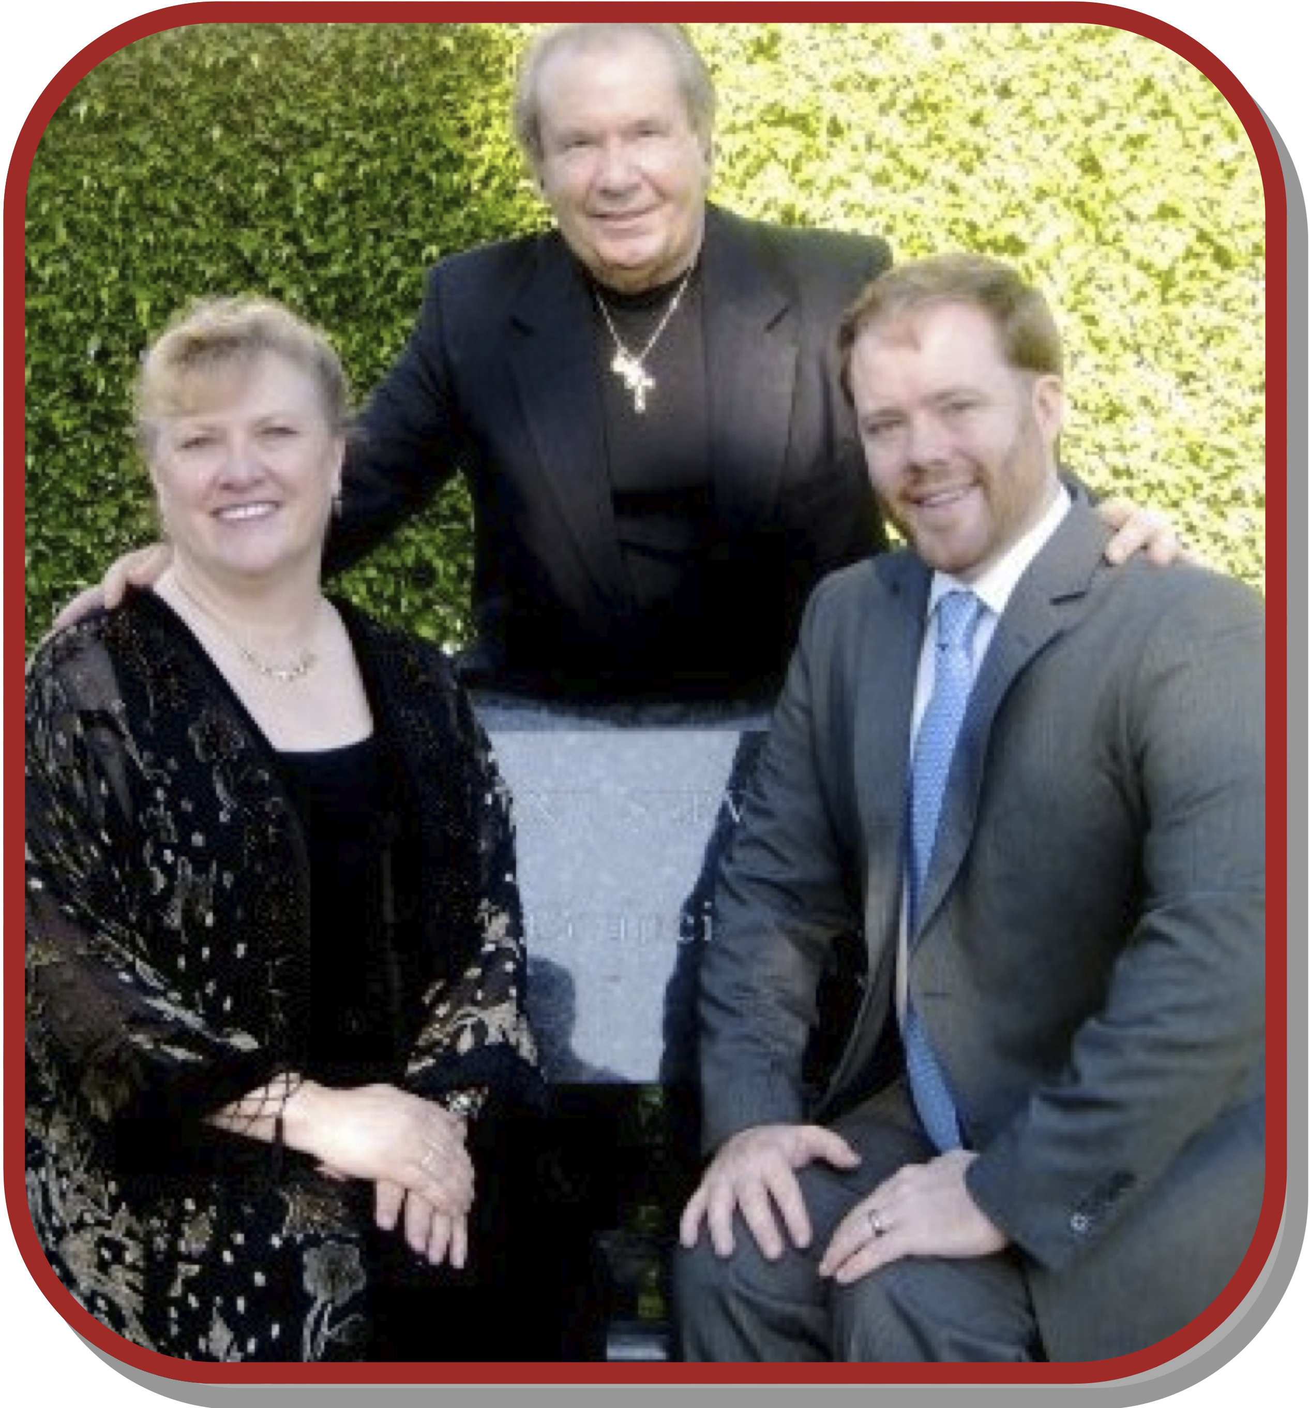***Songs of Devotion & Faith***

*A joint concert with* ***Southwest Florida Italian Opera!***

Italian baritone **Dino Valle** will join with St. John’s favorite soprano**, Ellie Roberts** (*née VanderMeuse*),

**Tom Oram** & the **Saint John the Evangelist Adult Choir** to fill our church with soul-stirring sacred music from some of history’s greatest operas & oratorios!

*This sacred program will include selections from the works of*

***Verdi, Puccini, Mascagni, & more!***

*Upcoming* **Friday, February 24th**, at **7 PM** in the church: **Repent & Believe**, our annual Lenten Concert!